April 2024
I Am Because We Are Together

Autumn Edition

In December of 2023, 10 young women from Young Mercy Links Victoria and South Australia travelled to Cambodia for a 10-day immersion accompanied by Young Mercy Links Coordinators Angela Scarafilo and Gaby Kinsman and Young Mercy Links (YML) Mentor Meredith Evans.
Over the year leading up to the trip, members raised funds to provide materials for a house building project they would be taking part in, through the work of the Jesuit Refugee Service (JRS). The intention of the journey was not only immersion with the people, culture and extensive history of Cambodia, but also to learn lessons in community and togetherness. The structured program involved education and reflection sessions, rituals, hands on volunteering and cultural activities and excursions.
The group spent several days in Phnom Penh, where they learnt about contemporary Cambodian culture, and also reflected on the Khmer Rouge genocide, so recent in the country’s history. Through visits to the Genocide Museum and Killing Fields, the experience provoked a broader discussion about the brutal regime and its effects on modern day Cambodia. Participants were shocked and deeply moved by the atrocities that occurred and much time was spent in personal reflection. While confronting, the importance of remembering and understanding this history is integral to the reconciliation and peace of the Cambodian people, and inspired empathy and an unwavering sense of justice within us.
After a visit to the Cambodia Peace Gallery, we were astounded by the culture of Cambodia and how its Buddhist roots allowed a unique path to forgiveness and ultimately peace. We pondered on how useful this approach would be for current global conflicts.
The YML Group then paid a visit to Bishop Kike Figaredo in Battambang. Also known as the ‘Bishop of Wheelchairs’, Kike has worked alongside Sister Denise Coghlan for over 30 years and devoted his life to serving as an advocate and support system to people suffering disabilities. Many of those afflicted are from the many landmines still littering the landscape, a remnant of the Khmer Rouge regime. In our meeting with Bishop Kike he emphasized the importance of community and solidarity. We were invited to join him and the children of the Arrupe Centre on an early morning walk. This time together and opportunity for encounter had a profound impact on our members and their understanding of resilience and gratitude. Even with language barriers and physical restrictions, we journeyed together singing and laughing.
We then spent 6 nights at the Metta Karuna Reflection Centre in Siem Reap with Sister Denise Coghlan, who has similarly devoted her life to the people of Cambodia. Our time here felt like a home away from home. Once we drove through the front gates an instant air of calm and a true feeling of being present washed over us. Sr Denise and her staff warmly welcomed us and gave us refuge from the hustle and bustle of our own thoughts and the personal struggles of the people that weighed us down.

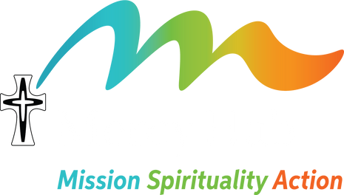
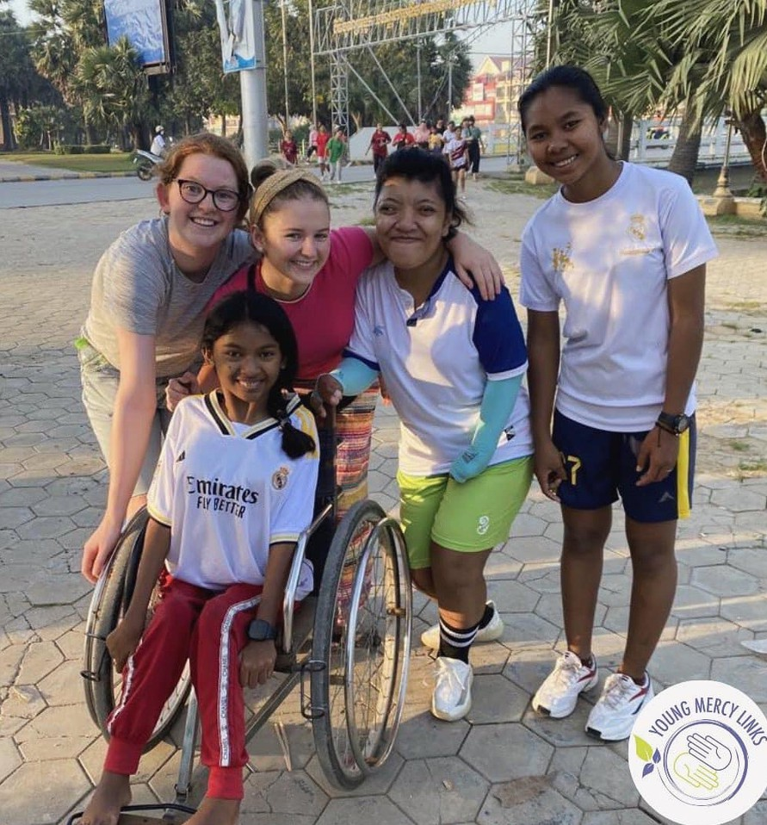
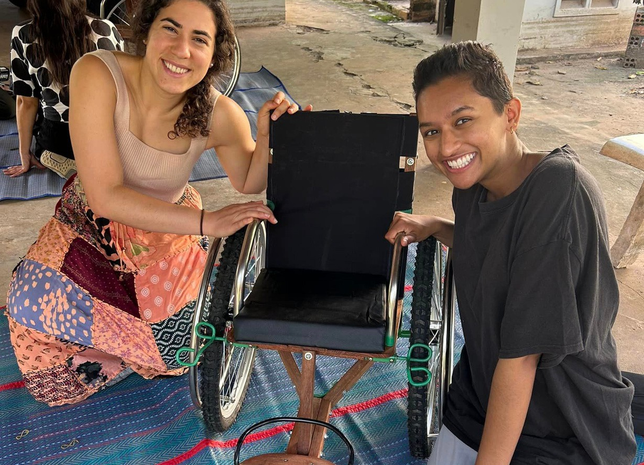

1
The Mercy Hub acknowledges the traditional custodians of the land on which we work, the Wurundjeri people of the Kulin nation. We pay our respect to their elders past and present.

Page one story continues...
Amongst experiencing Cambodia’s rich cultural treasures, including a slightly disappointing sunrise at the otherwise beautiful Angkor Wat, the group were also introduced to Reth, he is an inspiring landmine survivor, who heads the house-building project for vulnerable people. On perhaps one of the hardest-working days of our lives, the group assisted in building a house for a young, single mother with an intellectual disability. We found that, in cases such as this, the community comes together to help build these houses, all going unpaid, but doing it for the love of their family and neighbours. After, we had a session with Reth, where he spoke of his life story and the many challenges and obstacles he has faced as a double amputee. It was one of resilience, determination and giving back. We heard about his work with the JRS and his role in the International Campaign to Ban Landmines which led to him travelling the world as an advocate and accepting the Nobel Peace Prize for the team’s efforts.

Holding this golden medal and being witness to Reth’s strength and determination brought our members to tears. It was a transformative encounter we will never forget. We also helped Reth and his team construct several wheelchairs specifically designed for the uneven Cambodian terrain.
During our time constructing the walls and flooring of the house for a young woman Tak Na Si, we shared in an invaluable sense of community, compassion and belonging, that often lacks in our busy lives in Australia. Since returning, Tak Na Si’s family and community will now have completed the remainder of the build. The time we shared will be treasured by each and every one of us, not only for the learning and memories we will keep, but for the togetherness we have experienced and the connection with the land, the community and each other. As the proverb goes, ‘I Am Because We Are’.

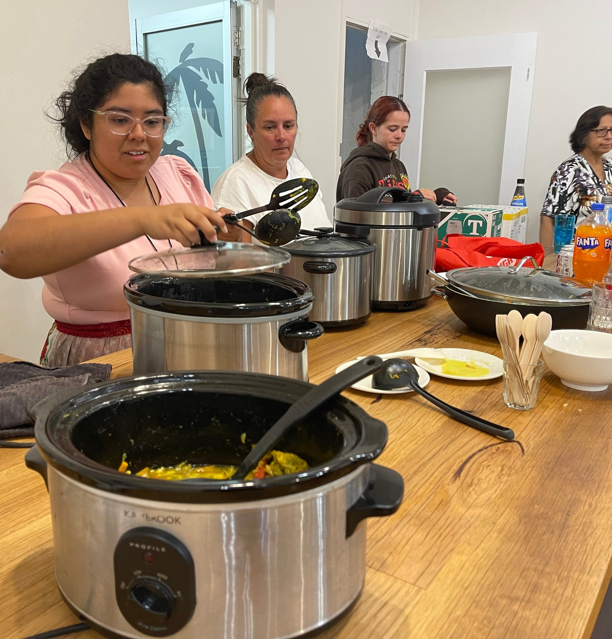
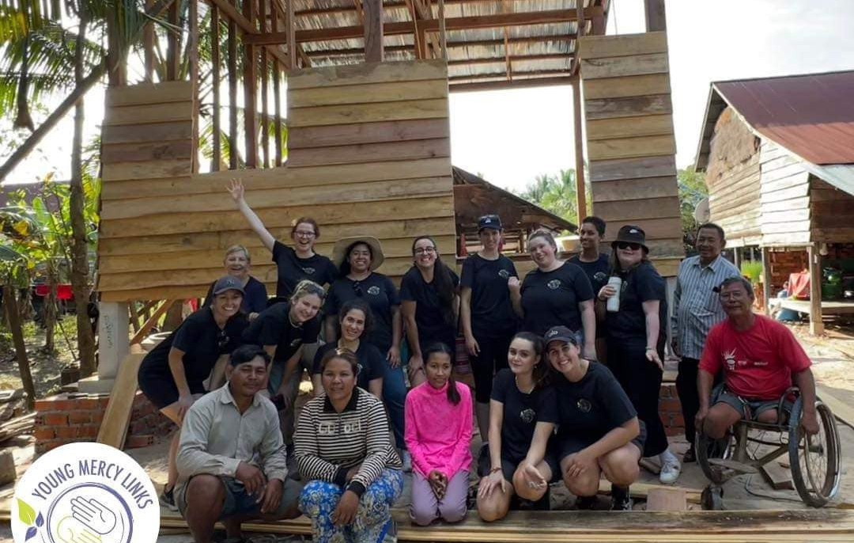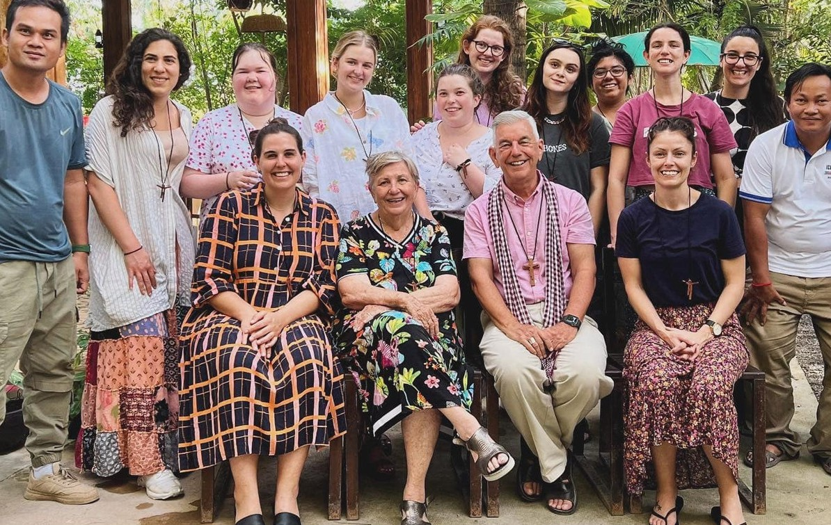

With thanks, your support was vital!

To say thank you to all who supported and donated to Young Mercy Links’ volunteer immersion in Cambodia, YML hosted a Khmer Curry Night.

Family, friends, Sisters and all who participated, donated and/or contributed to their fundraiser events were invited to the Mercy Hub for a bowl of warm Cambodian-inspired curry. The night began with a hybrid zoom presentation together with YML South Australia; where members shared their experiences of the trip. Everyone then continued to share and mingle over warm curry that the YML members had prepared themselves. It was wonderful for them to share what they had seen and done and they thank all who contributed to making the trip happen.

2

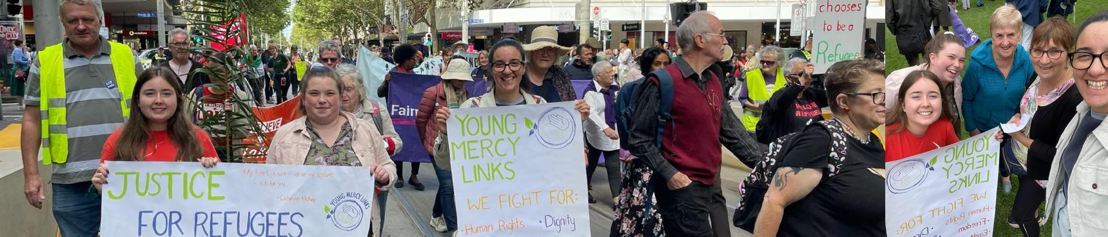
Young Mercy Links (YML) Victoria ran a two-day workshop at the Mercy Hub for year 12 students leaders from Victorian Mercy Schools.
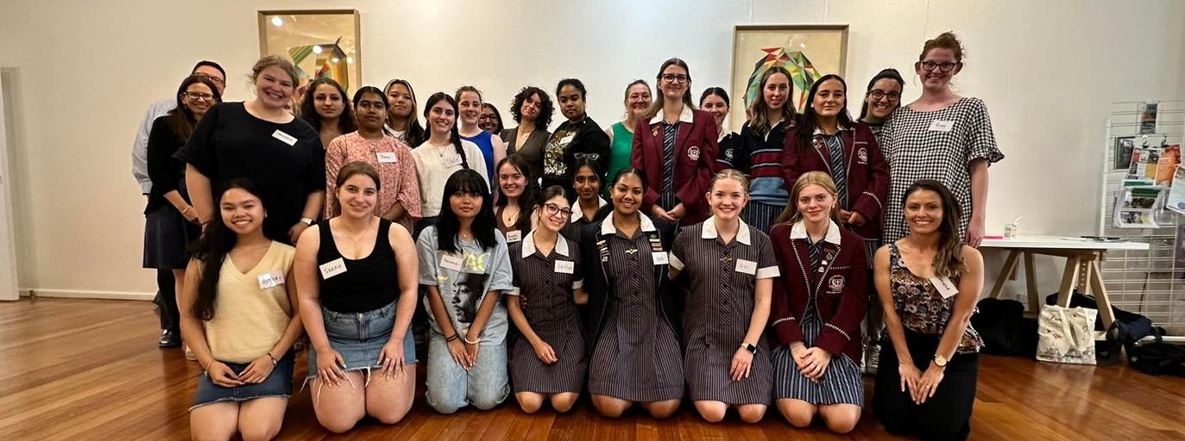
The students spent their time together learning about leadership and Mercy, as well as considering how to ignite the charism and passion for social justice in each school community. YML members will act as mentors throughout the year to the young leaders as they take on their new role.
Young Mercy Links Victorian Coordinator, Angela Scarafilo, said “It was an honour to work with these young people and hear their visions. Catherine McAuley’s legacy is in safe hands”.
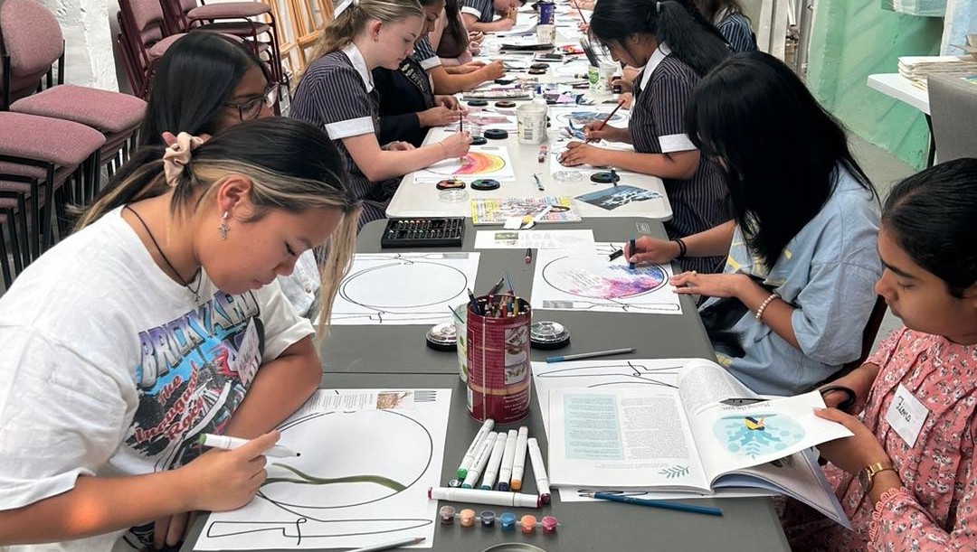
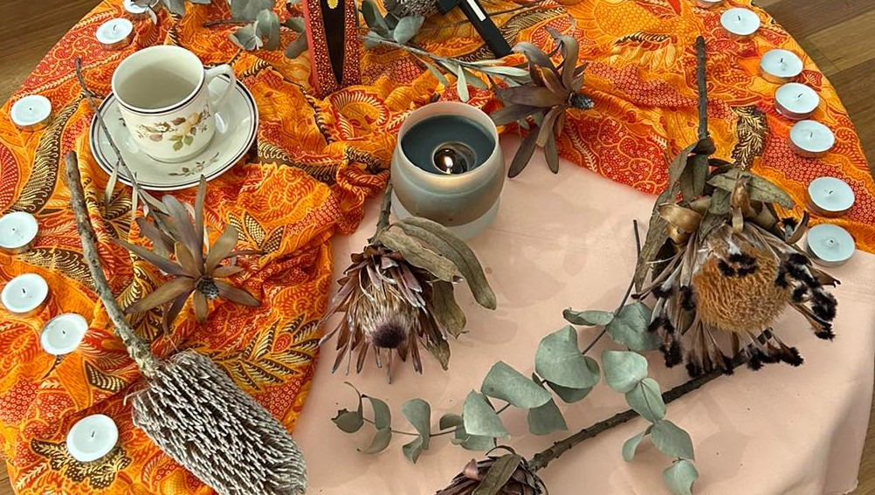

Resilience in a commitment of cause..
It happens each year quietly, Young Mercy Links (YML) members participate in the Palm Sunday Walk for Justice for Refugees. The walk is from the State Library to Parliament Gardens, asking for permanent visas for all refugees. Each year YML members determinedly attend, fighting for justice for all refugees, a cause so very dear to YML, who believe that every human being deserves to be treated with respect and dignity and has the right to be free and to be safe.
At it’s core, YML feel it is extremely important to participate in events like these, to spread awareness and come together to fight for human rights for all individuals. Together we can make an impact and challenge those decision makers and those in positions of leadership to make necessary changes, and not stop but rather contribute to a better, more just world.

3

A big welcome to the Mercy Hubs newest staff
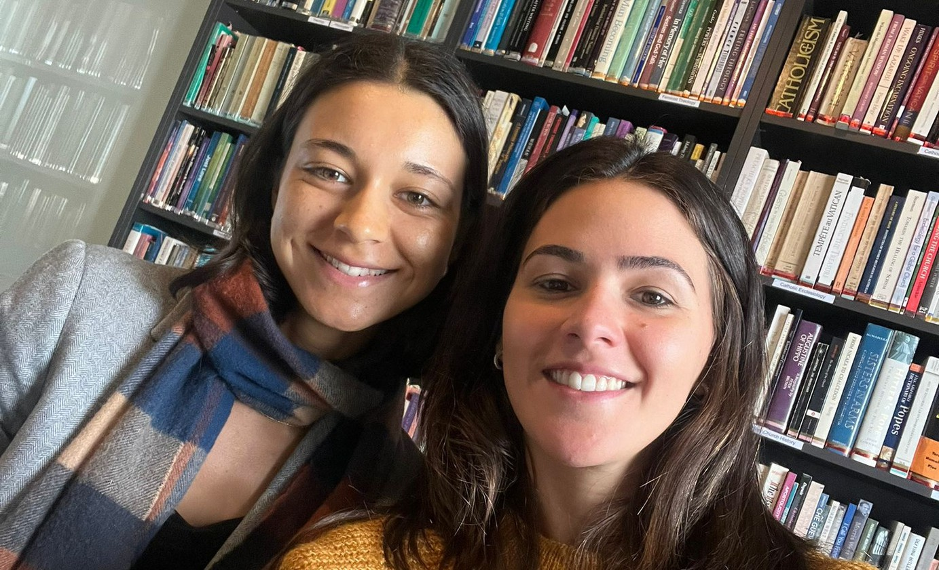
(pic Elizbeth Diaz (right) and Lucy Eaton)

Introducing Elizabeth Diaz and Lucy Eaton!

Eli and Lucy are joining us with a vibrant burst of energy and creativity, ready to take the lead in crafting engaging activities and innovative programs here at the Mercy Hub. Their expertise and enthusiasm are exactly what we need to bring our community together, offering experiences that inspire, educate, and entertain. Let's extend a warm welcome to Eli and Lucy as they embark on this exciting journey with us, shaping the future of our programs and ensuring the Mercy Hub remains a dynamic and inclusive space for everyone.

Inspired, created and revealed
First term of Art Class has been a resounding success with many returning students and also new participants. Our amazing Art teacher Phil Kreveld, inspires the creative spirit and along the way connections are made, friendships borne.

The Art Exhibition held for last year’s group will definitely be something we will work toward for this group. It was great to witness the fruit of hard work and confidence to show it to the public.
Special thanks to the Community Bank Clifton Hill- North Fitzroy for funding our classes and to our teacher Phil for his continued support.
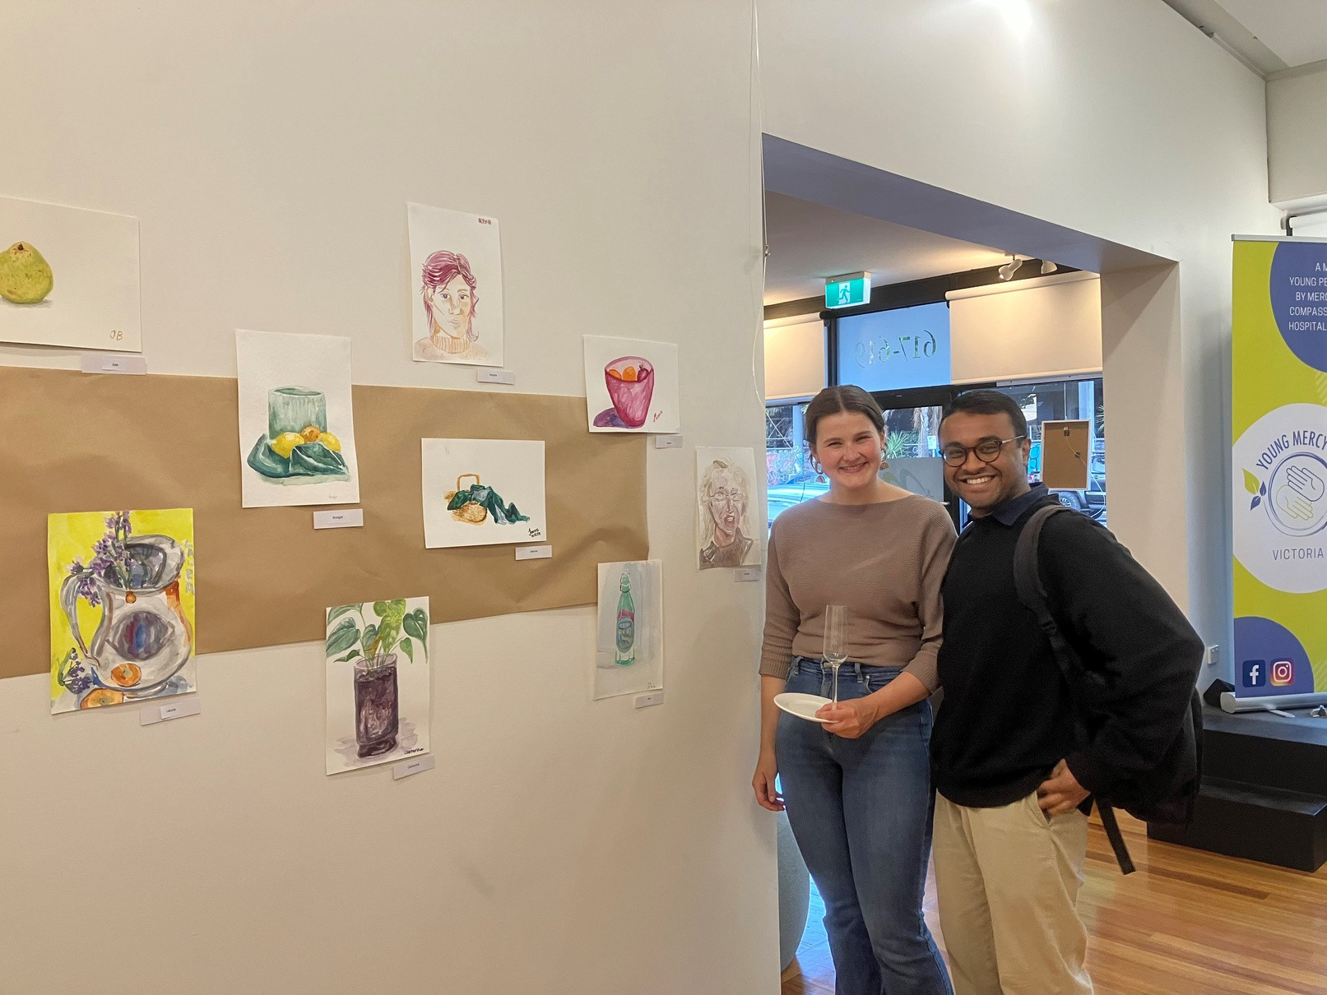

Poetry continues at the Mercy Hub

Comfortable Cuppa
Join us in person or via Zoom, everyone is welcome!

Usually every first Sunday afternoon of every second month, you will find a group of poetry lovers sharing the power and beauty of words through verse.

A theme is picked at each meeting, giving everyone a chance to research a themed poetry piece. This process can take you down unexpected paths and challenge ideas.
You can look forward to the ongoing sessions of Mercy Hub’s Comfortabe Cuppa.
We are grateful this year to Dr Frances Baker RSM who led us in prayer and reflection via zoom during Lent. Each weekly reflection considered “Works of Mercy” in relation to: historical context, theological framework and some connections in this post Chapter time.
You are invited to join our weekly in person sessions at 607 Nicholson St, Mercy Hub, starting at 10:30 AM, followed by a Cuppa. You can also join our zoom session on the last Wednesday of each month, same time.

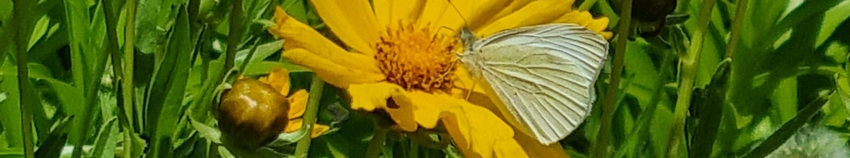
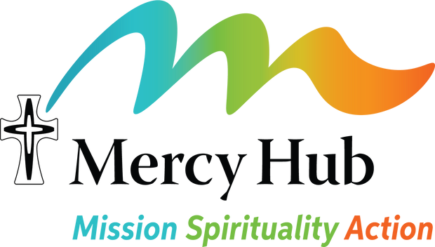
4

