We hope you enjoy reading this May edition of Mercy Hub Highlights

Mercy Hub Highlights

May Edition 2020

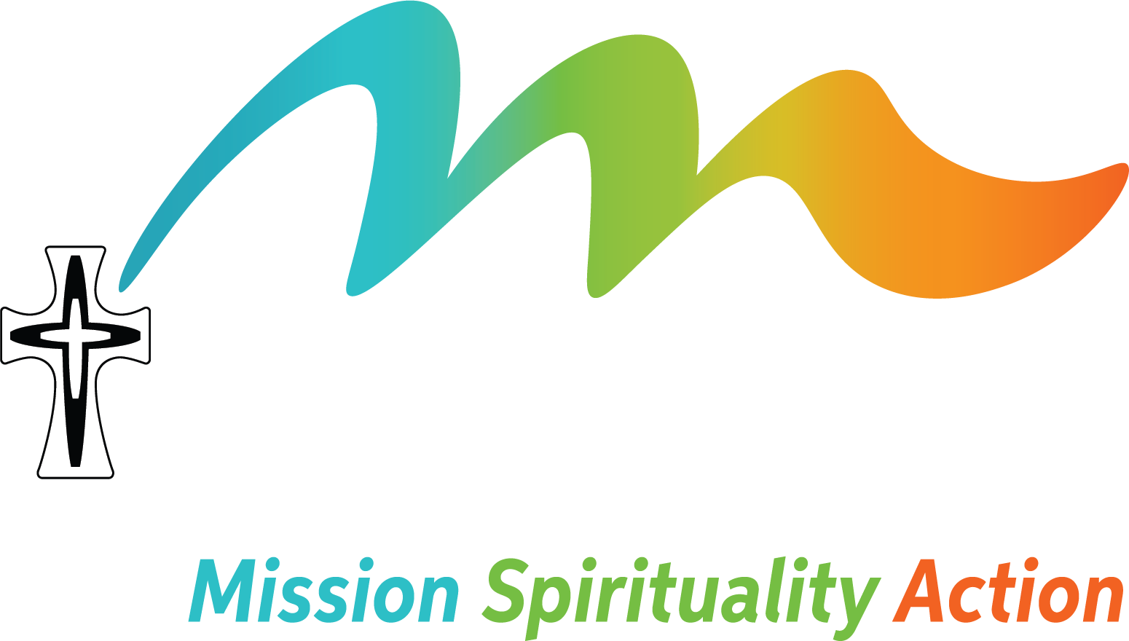
Young Mercy Links Letter Writing Project - Angela Scarafilo (YML Coordinator)
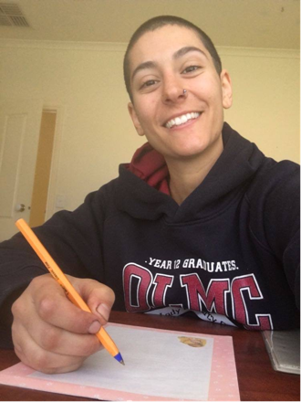
In these times of isolation and social restrictions our members are keeping busy and connected with our extended community. Residents in our Mercy Health Aged Care Facilities have felt especially lonely during COVID-19 due to strict limitations on visitors into their facilities. So Young Mercy Links has begun a pen pal initiative to write to some of these isolated residents. We know this correspondence will be as beneficial to our members as it is to the residents and we are hoping once all this passes our pen pals will be able to meet in person and put a face to the handwriting.
Juliet Talarico
Anniversary Celebration of Laudato Si’
On Sunday 24th May, Mercy Hub hosted a very special online celebration of the fifth anniversary of Laudato Si’. Pope Francis’ influential encyclical on ecology and climate change continues to inspire and challenge us as we live into the reality that ‘everything is connected’, especially in these days of coronavirus. Welcoming over 100 participants from all around Australia and from Aotearoa New Zealand, Margaret Moore rsm (Mercy Hub Manager) invited them to bring their own concerns into dialogue with in-depth reflections given by Adele Howard rsm, Chris Hill, Environmental Sustainability Manager, and renowned biblical scholar Veronica Lawson rsm.
Adele Howard began the reflection process by reminding participants that Laudato Si’ focuses on environmental and economic issues; social justice and ecological needs are linked, and ‘we flourish, or perish, together’. Chris Hill drew on compelling images and data to describe the context of the climate crisis - locally, regionally and globally. Veronica Lawson asked ‘what do we hear that speaks to Earth’s distress?’ in the Lukan Ascension narratives. Just as the disciples were commissioned by Jesus to bring God’s word of love and care for all creation even to the ends of the earth (Acts 1:8), we, as their successors, are called to incarnate the compassion for the Earth community that Jesus showed.
Participants were then invited to reflect in small groups on how their issues of concern were addressed by scripture and by the social and environmental teachings of the Church found in Laudato Si’. In encouraging action, Chris Hill then highlighted examples of practical actions for sustainability - locally, regionally and globally.
The afternoon concluded with the common prayer for the fifth anniversary of Laudato Si’, in which all joined their voices together, uniting with others from around the world.
The hosting of such a vibrant event on zoom, involving presenters in two different states and three locations, and Hub staff physically distanced in separate spaces within the Hub, was a technical challenge! However, participants greatly appreciated the opportunity to reflect together on how we are called to care for earth in these times, and to be enriched by the speakers’ insights. Anne Pate
Face Masks for Papua New Guinea - Or mask mania down the wombat hole!
Sewing face masks was marvellous therapy for our team of 17 seamstresses – Sisters, their families and friends as well as our Young Mercy Links SA and Elizabeth Young’s Vinnies Youth team. It has been a welcome relief in our COVID-19 incarceration and even more so, a joy for our Sisters in Papua New Guinea. If we could but have shared the moment when Hagen Sisters, Claudia and Theresia waved with delight the first postal package on FaceTime!
We are very close to 1500 masks made as we write. The face masks contributions came from our Mercy family all across Australia for our Mercy communities in Papua New Guinea. Truly a very fine ISMAPNG effort!
The masks are mostly on their way to Mt Hagen, Wewak, Kunjingini, Pumakos, Yarapos and Aitape. As we expected, there have been challenges in getting them to the Sisters, so they are arriving after some weeks on their journey. The most significant issue was that there were very few freight flights leaving Port Moresby as the national and provincial borders were closed.
Thank you to all our donors, those who gave directly and through the stimulus fund, which made it possible to send the parcels express. We are pausing the masks production for the present to await feedback from PNG recipients.
Marg Ryan and Mary Geason
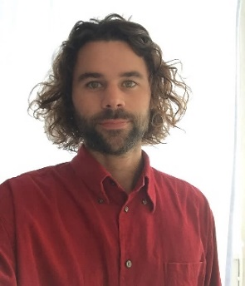
Hub Staff Member Profile
Liam Gubbins is the Administration Assistant at the Mercy Hub. Liam works at the Mercy Hub three days a week. Liam’s love of Mercy began at Emmanuel College Warrnambool. After high school Liam went on to study an undergraduate degree in Digital Media at Australian Catholic University. Liam feels very fortunate to continue to be involved in the legacy and traditions of Mercy. When Liam is not at the Hub he spends his time writing, recording and playing live music.
Comfortable Cuppa at the Mercy Hub – continues via zoom!
This prayer continues every Wednesday morning, bringing together sisters and staff from around Australia. Gospel readings, poetry, music and personal reflection enrich our prayer.

