Facemasks for Mercy Health

Mercy Hub Highlights

July Edition 2020

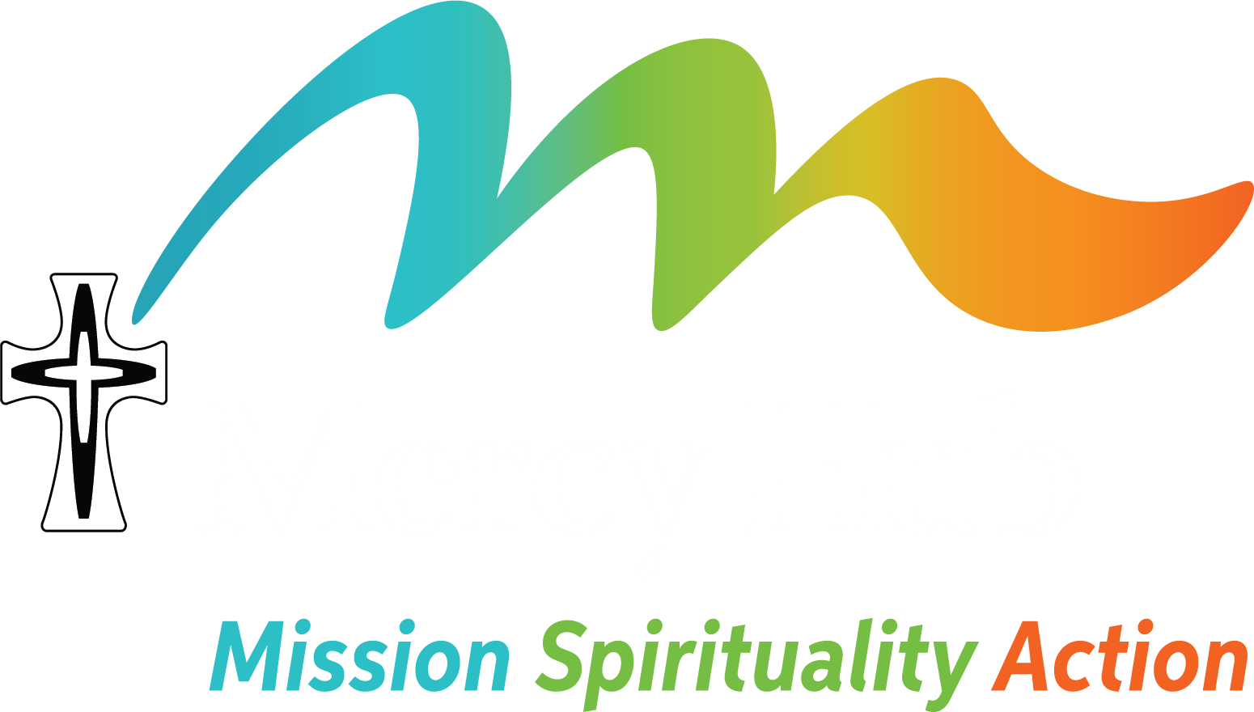

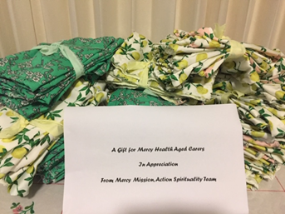
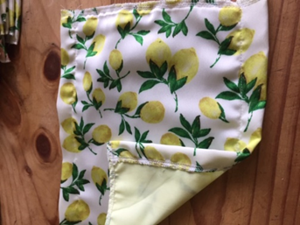
Sr Evelyn Crotty, Institute Leader, put out a call for help for Mercy Health in what is clearly a critical time and one of deep anxiety for the welfare of residents, staff and the families at this time, more especially in Melbourne and regional Victoria. So Mary Geason and Marg Ryan responded as rapidly as they could, as is the goal of the Mercy Action and Spirituality Hub team, to respond to the needs of contemporary mission, in particular this urgent need for health workers to have access to masks, not only at work, but when travelling to and from work.
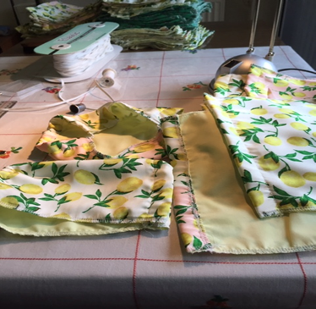

NAIDOC Celebration
In celebration of what would traditionally be NAIDOC Week (5-12 July) staff at the Mercy Hub, sisters and friends joined in a short reflection to commemorate the week during Comfortable Cuppa. The reflection led by Anne Pate acknowledged and celebrated the achievements of Aboriginal and Torres Straight Islander People.
Further online events will be planned in the coming months to celebrate this year’s newly proposed date (8-15 Nov).

Journeying with Mercy – A reflection by Anne Pate

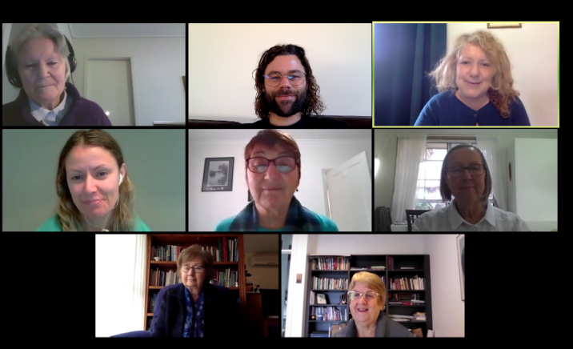
As I leave my role as Program & Activities Facilitator, I am grateful for the opportunity to reflect on my time at the Mercy Hub. Since joining the Mercy Hub team in December 2017, I have had the privilege of working alongside dedicated sisters and lay staff in this exciting and growing ministry. The Mercy Hub is active in the local Carlton community, provides a home base for sisters involved in regional and global mission, and now hosts online events such as the weekly Comfortable Cuppa prayers and Laudato Si’ celebration which have reached sisters and others across the Institute and beyond. It has been wonderful to participate in the growth of these initiatives and to see what can happen when we step into new ways of being mercy in the world. I came into the Mercy Hub team without a background in the mercy tradition, as a Protestant lay woman and Ignatian spiritual director. I have learned so much during these past few years, and been personally challenged, in ways which will take time for me to fully recognise. What stands out for me most in this moment is my experience of being welcomed, of being taken up into this developing community and given space to grow. The welcome I received is extended to all who come, to the many different people who share conversation around the Mercy Hub table, as we ‘waste some time with visitors’ in the best possible sense of Catherine’s famous words. My encounters with mercy have also challenged me to be mercy in the world - to give expression to the love of God in practical actions, large and small.

Although I am leaving the Mercy Hub to take up full-time study, I will be continuing in my role as Mercy Associates Network Facilitator for Victoria, and look forward to further adventures in mercy in the years to come.

Keeping in touch during COVID 19 – Rosemary Patterson
Rosemary continues to build relationships with the African Families through connections made locally in the Carlton area. “I was able to visit some of the women between lockdowns and now appreciating their excitement at receiving phone calls and texts. An African Women’s exercise class online that I was invited to was a little more strenuous than I expected!”

