We hope you enjoy keeping up to date with all that’s happening at the Mercy Hub!
Facemasks Project for the People of PNG

Mercy Hub Highlights
April Edition 2020

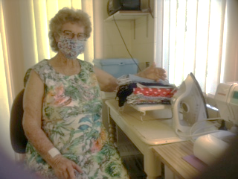
As you know, Margaret Ryan is on a mission making facemasks for the people of Papua New Guinea. The virus has been identified in Port Moresby and other parts of PNG, and we can be sure it will spread quickly through very vulnerable populations, and that these same populations will not be well prepared. We know of the struggle that Australia has had to acquire adequate Personal Protective Equipment, even for health workers, let alone provide masks for people who might be in the community with symptoms of the virus. There are Sisters, relatives and friends of Sisters around the Institute who are assisting at their sewing machines and sewing up masks at a rapid rate. If you would like to assist, you can find a demonstration and facemask pattern at the following link: https://youtu.be/6gcLp0y-Mfg when you have made even a few masks, if you post them to Sr Margaret Ryan, P O Box 504, Carlton North, 3054, Marg will arrange for distribution to our Sisters in PNG.
Many thanks to the many helpers around the Institute so far, well done! If you are unable to sew facemasks, and would like to make a donation to help defray the costs of materials and postage of the masks, you could write a cheque payable to ISMAPNG-CTAL, with a note saying it is for facemasks, (post to Sr Margaret Ryan, P O Box 504, Carlton North, 3054).
Comfortable Cuppa at the Mercy Hub
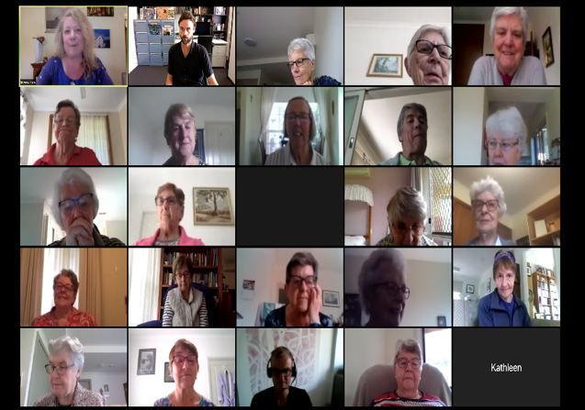
As with so much in our lives, the coronavirus pandemic has meant an unexpected move to an online format. From Wednesday 15th April, the Mercy Hub Comfortable Cuppa reflections continue to be offered online.
We are delighted that so many sisters from around Australia are able to join in these online gatherings during this Easter season. The light of the Risen Christ has indeed been present to us. Anne Pate – Mercy Hub
Mercy Global Presence
Mercy Global Presence continues to be supported across our Institute, from the Mercy Hub, through regular Zoom based meetings. The first meeting of Segment 2: Mercy, a lively and enriching exchange, was held on Tuesday 14th of April with approximately 40 participants.
It was based on the theme: Faith Traditions and Mercy.
For more information and dates: https://institute.mercy.org.au/mercy-global-presence/
Adele Howard rsm National Coordinator, MGP

African Parents Get Together
During these disturbing and challenging weeks I am continuing to build stronger relationships with the African families who have been meeting with me at the Hub. For now our communication happens through text messages and phone conversations. They are amazing people and are so grateful to have the opportunity for text and phone chats to keep in touch. Their needs are great and as I listen, I’m finding small ways to support them ‘from a distance’ while Covid-19 restrictions are still with us.
I look forward to our face-to-face gatherings with them at the Hub in the not too distant future. Rosemary Patterson rsm
Laudato Si’ Week Celebration on Sunday 24th May
Pope Francis is inviting communities around the world to celebrate the five-year anniversary of Laudato Si’ during Laudato Si’ Week (16th-24th May). To mark this significant milestone, Mercy Hub will host an online gathering on Sunday 24th May from 2.00-4pm. We are called to celebrate the actions of the past and to accelerate our actions for the years ahead. Veronica Lawson rsm, Adele Howard rsm, and Chris Hill (ISMAPNG Environmental Sustainability Manager) will each share their valuable reflections, and there will be space for conversation. More details coming soon.
A few words about Sibling Café - Nicholson St, Carlton North. Melbourne.
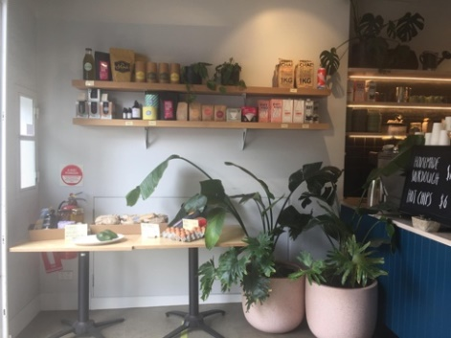
We are very happy to see that Sibling remains open for takeaway food and coffee. There are queues of people, keeping physical/social distance patiently waiting outside for their coffee and muffin/cake/savoury snack, and enjoying the autumn sunshine during these leisurely days. Sibling recently contacted to let us know that they have adapted to a changed environment by offering pre-prepared meals (ready to heat) that can be delivered around Melbourne and the surrounding suburbs. See below for offer of assistance and gratitude to Mercy Sisters from Jarrod Briffa,CEO Sibling. (extract from letter)
“We are currently selling pre-prepared meals (ready to heat) via our online store which I thought might be useful for some whilst the isolation measures are in place. I also wanted to enquire if the Sisters were arranging relief meals for any in-need community members that you work with? We have sent out 500 relief meals to Dandenong today and we are working with a domestic violence Charity to provide meals for the women and their dependents next week. We have a lot of staff on Job Keeper and two commercial kitchens ready to be used if there are orders for relief meals. We can easily produce a few thousand relief meals each week so we feel we can really help to be useful during this time if orders are coming in that would fund this service.”

Recently Kathleen Williams sent these words of appreciation about Sibling Café to Mercy Hub.
‘The Sibling cafe is something I feel very glad about, and proud that the Sisters of Mercy have set up this partnership. The young people who run it would not use the term 'ministry', I'm sure, but the work they do is certainly that: giving the opportunity for young people who otherwise would not have a chance to be employed and trained on the job; donating excess takings to other disadvantaged groups etc. I see it as a real ministry on our part too, a contemporary ministry that enables young people to be agents for promotion and support of those with less - little - opportunity to learn; a ministry of the young to the young. I've watched the sense of dignity and achievement as they are respectfully 'tutored' in what it means to be in the hospitality industry.’
If you know of any groups in Melbourne who would appreciate support for meals during this time please contact Sibling: www.sibling.org.au

